**EE3060 Probability – Proposed questions and answers**

Question 1:

In NBA West Conference are 15 teams, divided into 3 divisions, each division has 5 teams. And the division details are listed below.



At the end of the season, top 8 ranking teams will go into Playoffs (ranked by all 15 teams’ record). In Playoffs, the matching of two teams in the first round is totally based on ranking (1vs8, 2vs7, 3vs6, 4vs5). Those who have higher rank will get home field advantage in the first round.

Suppose every outcome of the standings have the same probability to occur.

Given that there are **3** teams successfully going into Playoffs in **Pacific Division**, what is the probability that **Lakers** and **Warriors** both going into Playoffs and having **home field advantage** in the first round?

Answer 1:

A: event that 3 teams of Pacific Division go into Playoffs

B: event that Lakers and Warriors both make it to Playoffs and have home adv.

Use Counting to solve this problem:

# of A: $\left({5 \atop 3}\right)\left({8 \atop 3}\right)3!*\left({7 \atop 2}\right)2!*10!$

Choose 3 teams out of 5, then pick 3 seats in Playoffs and Permutations. After that, the rest 2 teams in Pacific Division find spots out of NoPlayoffs. Finally, place the rest 10 teams.

# of A∩B: $\left({4 \atop 2}\right)2!\left({3 \atop 1}\right)\left({6 \atop 1}\right)*\left({7 \atop 2}\right)2!*10!$

Choose one team in Pacific Division (Except Lakers and Warriors), then find two spots in top4 for Lakers and Warriors. After that, place that picked team in some position in Playoffs, find spots out of NoPlayoffs for the rest 2 teams in Pacific Division. Finally, place the rest 10 teams.

P(B|A) = # of A∩B / # of A = $\frac{216}{3360}= \frac{9}{140}=0.0643$

Question 2:

In a classroom, 51% of the students have Facebook accounts, 31% have Twitter accounts, 39% have Instagram accounts. 19% have both Instagram and Fackbook accounts, 9% have both Twitter and Instagram accounts, 6% have both Twitter and Facebook accounts, 15% **only** have Instagram accounts. 9% don’t have any accounts. And a student in the classroom is selected randomly, find the probability that he/she **only** has Twitter account.

Answer 2:

By the problem, we can draw grpah below,

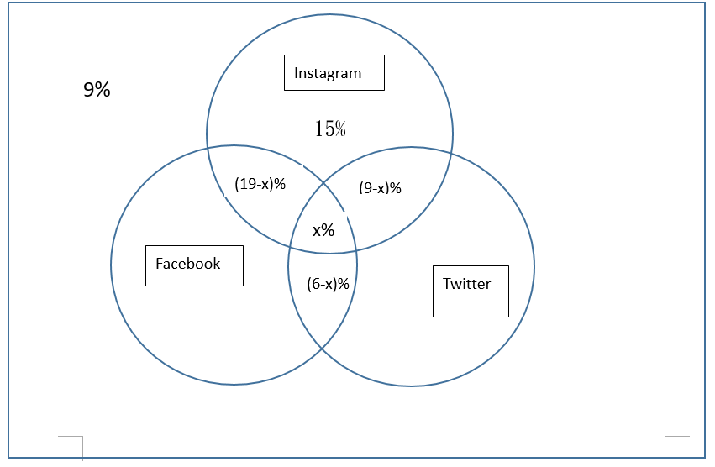

Set x represent the percentage of students who have all accounts at the same time.

In Instagram circle,

15% + (19-x)% + x% +(9-x)% =39%

* x = 4

In Twitter circle,

31% -( 4% + 5% +2%) =20%(answer)

Question 3:

Student A do a question and he maybe know the answer,or maybe not.The probability that he knows the answer is p, and the probability that he guesses the answer is 1-p.If he guesses the answer,the probability that he guesses right is 1/m.If student A does right in this question, what’s the probability that he knows the answer?

Answer 3:

Let c be the event that student A does right in this question,and k be the event that student A knows the answer



Question 4:

A basketball team consists of 6 frontcourt and 4 backcourt players. If players are divided into roommates at random, what is the probability that there will be exactly two roommate pairs made up of a backcourt and a frontcourt player?

Answer 4:

There are (10)!/25 different divisions of the 10 players into a first roommate pair, a second roommate pair, and so on. Hence, there are (10)!/(5!25) divisions into 5 roommate pairs. There are 6 2 4 2 ways of choosing the frontcourt and backcourt players to be in the mixed roommate pairs and then 2 ways of pairing them up. As there is then 1 way to pair up the remaining two backcourt players and 4!/(2!2^2) = 3 ways of making two roommate pairs from the remaining four frontcourt players, the desired probability is P{2 mixed pairs} = $\frac{{(C}_{2}^{6}*C_{2}^{4}*2*3)}{(\frac{10!}{5!*2^{5}})}$ = 0.5714

Question 5:

There is a 10 people badminton team in the Department of EE. 3 of them are freshmen, 4 of them are sophomore, the rest of them are junior. Now, they are going to participate in a contest. All of them will be divided into five groups randomly to play in doubles with the probability of every outcome equal.What is the probability of the distribution that everyone has a teammate with different grade?

Answer 5:

First, the sample space is $\left({10 \atop 2}\right)\left({8 \atop 2}\right)\left({6 \atop 2}\right)\left({4 \atop 2}\right)\left({2 \atop 2}\right)/5!=$ 945 ways

Apparently, 2 sophomore go with 2 freshmen, and the other 2 sophomore go with 2 junoirs, all of the 4 pairs should be permutations respectively.  
Eventually, there will be left 1 freshman and 1 junior.  
According to our analysis, $\left({4 \atop 2}\right)\left({3 \atop 2}\right)2!\left({2 \atop 2}\right)\left({3 \atop 2}\right)2!\left({1 \atop 1}\right)\left({1 \atop 1}\right)$ =216 ways

The probability of the distribution that everyone has a teammate with different grade are $\frac{216}{945}=\frac{8}{35}=0.228$